Project Report on

**PUBLIC BLOG APPLICATION**

at

**U. V. Patel College of Engineering**



|  |  |
| --- | --- |
| **Internal Guide:** | **Prepared By:** |
| Prof. Rachana Modi | Mr. Aum Jayeshbhai Radia  (19012011064) |
|  | Mr. Bhavin Kumar Jani (19012011142) |

**B.Tech Semester VII**

**(Computer Engineering)**

July-December, 2022

Submitted to,

Department of Computer Engineering/Information Technology

U.V. Patel College of Engineering Ganpat University, Kherva - 384 012

**U.V. PATEL COLLEGE OF**

**ENGINEERING**



**28/11/2022**

**C E R T I F I C A T E**

**TO WHOM SO EVER IT MAY CONCERN**

This is to certify that **Mr.Aum JayeshBhai Radia** student of **B.Tech. Semester VII (Computer Engineering)** has completed his/her full semester on site project work titled “**Public Blog Application**” satisfactorily in partial fulfillment of the requirement of Bachelor of Technology degree of Computer Engineering of Ganpat University, Kherva, Mehsana in the year 2021- 2022.

|  |  |
| --- | --- |
| **Prof. Rachana Modi** | **Dr. Paresh M. Solanki** |
| **College Project Guide** | **Head, Computer Engineering** |

**U.V. PATEL COLLEGE OF**

**ENGINEERING**



**25/11/2022**

**C E R T I F I C A T E**

**TO WHOM SO EVER IT MAY CONCERN**

This is to certify that **Mr.Bhavin Kumar Jani** student of **B.Tech. Semester VII (Computer Engineering)** has completed his/her full semester on site project work titled “**Public Blog Application**” satisfactorily in partial fulfillment of the requirement of Bachelor of Technology degree of Computer Engineering of Ganpat University, Kherva, Mehsana in the year 2021- 2022.

|  |  |
| --- | --- |
| **Prof. Rachana Modi** | **Dr. Paresh M. Solanki** |
| **College Project Guide** | **Head, Computer Engineering** |

# ACKNOWLEDGEMENT

This satisfaction that successful completion of any task would be incomplete without the mention of people whose ceaseless cooperation it made it possible, whose constant guidance and encouragement crown all efforts with success. We are grateful to our guide **Prof. Rachana Modi** for the guidance, inspiration and constructive suggestions that helpful usin the preparation of this project. We also thank our colleagues who have helped in successful completion of the project.

**Aum Jayeshbhai Radia|19012011064 Bhavin Kumar Jani|19012011142**

# ABSTRACT

Public Blog Application integrate blog software to facilitate effective communication with the users of web application.The main reason for making this project or the problem which we saw is that there is not a blog application existance on very ground level and there are very few application which exists but do not have that much facilities for reliable communication between the users, in this we are building this Public Blog application for the users who can simply put there ideas infront of several people by writing a blog other than that they can also like the ideas of other people and can comment on them.

INDEX

ACKNOWLEDGEMENT 4

ABSTRACT 5

1).INTRODUCTION 10

1.1 Purpose 11

1.2 Problem Statement 11

1.3 Overview 11

1.4 Objective 11

1.5 Tools And Technologies 11

2).Feasibility Study 12

2.1 Study Of Current System 12

2.2 Problem and Weakness of current System 12

2.3 Requirement of new system 12

2.4 Technical Feasibility 13

2.5 Operational Feasibility 13

2.6 Economic Feasibility 13

2.7 Implementation Feasibility 13

2.8 Requirement Validation 13

2.9 Literature Survey 14

3).Hardware And Software Requirements 15

4).Process Model 16

5).Project Planning 17

6).System Requirement Study 18

6.1 Functional Requirements………………………………………………………………………………………….18

6.2 Non-Functional Requirement 18

7).System Design 19

7.1 Use-Case Diagram…………………………………………………………………………………………………….19

7.2 Class Diagram 20

7.3 Sequential Diagram 21

7.4 Activity Diagram 22

7.5 Data Flow Diagram 23

8).Data Dictionary 25

9).Algorithm In Application 27

10).Test Cases…………………………………………………………………………………………………………….28

11). User Manual 29

12).Conclusion 37

13).Future Work 38

References 39

About College 40

# List Of Figures

4.1 Process Model 16

7.1 Use-Case Diagram 19

7.2 Class Diagram 20

7.3 Sequential Diagram 21

7.4 Activity Diagram 22

7.5.1 Data Flow Diagram(DFD Level-0) 23

7.5.2 Data Flow Diagram(DFD Level-1) 24

11.1 User-Manual Figure-1 29

11.2 User-Manual Figure-2 29

11.3 User-Manual Figure-3 30

11.4 User-Manual Figure-4 30

11.5 User-Manual Figure-5 31

11.6 User-Manual Figure-6 31

11.7 User-Manual Figure-7 32

11.8 User-Manual Figure-8 32

11.9 User-Manual Figure-9 33

11.10 User-Manual Figure-10 33

11.11 User-Manual Figure-11 34

11.12 User-Manual Figure-12 34

11.13 User-Manual Figure-13 35

11.14 User-Manual Figure-14 36

# List Of Table

1.5.1 Tools And Technologies 11

3.1 Hardware And Software Requirements 15

5.1 Project Planning 17

8.1 Data Dictionary User SignUp/Login Table 25

8.2 Data Dictionary Post Table 25

8.3 Data Dictionary Comment Table 26

8.4 Data Dictionary Like Table 26

10.1 Test Cases 28

# 1.INTRODUCTION

Public Blog Application is a web based application which will be working on the ground level or local level in which normal people can share there ideas and stories by writing a blog, While creating a blog the user can give a super short and appropriate title which suits his ideas or story when the user is publishing his blog along with that the user can also put an image to describe the view and imaginary thoughts of his blog after that user can give a brief introduction about his ideas or story and can post among people.

Talking on the advanced level the user can like the blog posts of other people and along with that they can comment on the other people’s blog application, trust me it’s very easy and simple.

The requirement component of the framework aids the web application in deciding features of blog software, to be included in a web application. For this, a weighted requirement checklist is presented. The design component provides a structural design of blog software which facilitates the developer in understanding the design of existing blog software as well as modifying it or developing a new one. The framework also aids the user during validation and verification of blog software integrated in a web application.

Both the web application owner and the developer are benefitted by the framework presented here. During integration of the blog software into a web application, the developer uses the framework to understand structure of the blog software. Also, by using design, the developer can understand the various interactions that occur between the different components of the blog software. The framework assists the web application owner to understand various requirements that are provided by the blog software and also to select them.

# Purpose

Public Blog Application is a web based application in which we will be working on the ground level or local level in which normal people can share there ideas and stories by writing a blog, and the other reason for making this project is that nowadays social media is evolveing and getting way better than the other, In a simple social media application we observe that it facilitates various functionalities like Reading, Giving Likes, Writing Comments, Sharing Ideas and that is pretty interesting and since then I wanted to learn this kind of things to evolve in this era, So the main purpose behind making this application is that a learning purpose and the other is to learn how this kind of application are growing by their great functionalities.

# Problem Statement

Public Blog Application is a web based application which will be working on the ground level or local level in which normal people can share there ideas and stories by writing a blog, While creating a blog the user can give a super short and appropriate title which suits his ideas or story when the user is publishing his blog along with that the user can also put an image to describe the view and imaginary thoughts of his blog after that user can give a brief introduction about his ideas or story and can post among people.

# Overview

Both the web application owner and the developer are benefitted by the framework presented here. During integration of the blog software into a web application, the developer uses the framework to understand structure of the blog software. Also, by using design, the developer can understand the various interactions that occur between the different components of the blog software. The framework assists the web application owner to understand various requirements that are provided by the blog software and also to select them.

For this, a weighted requirement checklist is presented. The design component provides a structural design of blog software which facilitates the developer in understanding the design of existing blog software as well as modifying it or developing a new one. The framework also aids the user during validation and verification of blog software integrated in a web application.

# Objective

Public Blog Application is a web based application in which we will be working on the ground level or local level in which normal people can share there ideas and stories by writing a blog, and the other reason for making this project is that nowadays social media is evolveing and getting way better than the other, In a simple social media application we observe that it facilitates various functionalities like Reading, Giving Likes, Writing Comments, Sharing Ideas and that is pretty interesting and since then I wanted to learn this kind of things to evolve in this era, So the main purpose behind making this application is that a learning purpose and the other is to learn how this kind of application are growing by their great functionalities.

# Tools And Technologies

The Tools and Technologies are as follows:

|  |  |
| --- | --- |
| Front-End Development | React and HandleBars |
| Back-End Development | Node.js |
| Database | MongoDB |
| IDE | Visual Studio Code |
| Database Software | MongoDB Compass |

***Table 1.5.1***

# 2.Feasibility Study

This project needs support from all people who are eagerly exicited to share there ideas among each other and they should adopt new technology with the help of our application. This will make their work easier and much more simple, by simply and easily writing there ideas into our application.

# Study Of Current System

Nowaday there are so many blogging websites in the internet which has so many active users writing there thoughts over the internet but the problem which I observed nowadays was that people are writing there blogs on internet but there is no any current system in which people cannot post negative things on the internet and that what I want to make it possible.I want users to post only positive thoughts while publishing there ideas.

And the reason why I want to develop this project is that nowadays social media era is evolving day by day and to make a way from that I also wanted to learn how to make this kind of applications.

# Problem and Weakness of current System

* + - Lack Of Quality content
    - No Clear purposes of writing topic
    - Negative Content
    - Mixed Content
    - Bad UI

# Requirement of new system

To Remove problems of current scenario we require new system which has to fulfill the characteristics shown below:

* + - Only Positive Blog Should Be Posted
    - Rich UI/UX
    - Easy Clickables
    - Simple Image Posting along with blog
    - Edit Delete Rights To the user
    - Simple Blog Format

# Technical Feasibility

Technical Feasibility current resources both hardware software along with required technology are analyzed/assessed to develop project. This technical feasibility study gives report whether there exists correct required resources and technologies which will be used for project development. Along with this, feasibility study also analyzes technical skills and capabilities of technical team, existing technology can be used or not, maintenance and up-gradation is easy or not for chosen technology.

We are using Visual Studio Code to develop this application with the help of node.js language and MongoDB Database. We are pretty familiar about these technologies and our hardware also supports this technology.

# Operational Feasibility

While describing the operational feasibility it is the measure of how well our proposed system solves the problems, So answering it well Our System solves the major problem which is no negative content and simple user experience over users session in pur website.

We have tried various technicality and traits to much our proposed system easy and simple.We have used REST API to fetch the uploaded data from the server effectively along with that we have also used Simple Logic building Skills to develop this project at our best.

# Economic Feasibility

According to me economic feasibility are the economic benefits from the project and the economic costs of the project, But according to this project if we talk about the Economic feasibility before deploying the project we never deal with economic costs because in this generation every thing and every information is free over the internet and after deploying the project if we want to economic benefits from the website we can bring more and more traffic on our blog website and after that we can monetize the website and run google ads on it and through that we can earn money.

# Implementation Feasibility

Operational feasibility assesses the range in which the required software performs a series of levels to solve business problems and customer requirements.

We are making our project as simple as possible so that the user find it easy to work with and can easily handle the records and other essential data.

# Requirement Validation

* + - Use Must Signup Before writing the blog
    - User should not register anonymous details
    - User need to specify unique username
    - User should not write irrelevant content

# Literature Survey

* + - In Our Project “Public Blog Application” to understand the removal of toxicity in the blog content to make the content more efficient and precise we have gained literature survey from.

Author:-Shaunak Varudandi

# Topic:- Toxic Comment Classification using LSTM and LSTM-CNN.

Site:-<https://towardsdatascience.com/toxic-comment-classification-using-lstm-and-lstm-cnn-> [db945d6b7986](https://towardsdatascience.com/toxic-comment-classification-using-lstm-and-lstm-cnn-db945d6b7986)

* + - To Understand how to fetch the registered data from the database while dealing with MongoDB I have gone through,

Author:-W3C Resource

# Topic:- Fetch Documents from collection in MongoDB.

Site:-<https://www.w3resource.com/mongodb/mongodb-queries-from-collection.php>

* + - Secondly to learn how a blogging application is built in node,js we have gone across many websites and understood how to make a efficient project by using simple line of code and what databases to use for easily retrevial of the data through the REST API.

Author:-Vegibit

# Topic:- Node.js Blog Tutorial

Site:-<https://vegibit.com/node-js-blog-tutorial/>

* + - Thirdly to know how to add the comment on the blog feature I have learned from,

Author:-Reddit.js

# Topic:- Comments on post

Site:-<https://makeschool.org/mediabook/oa/tutorials/reddit-clone-in-node-js/comment-onpost/>

* + - Now after learning all these things to know about the actual architecture on how to build a great UI(Frontend) so that the user finds it good to use our application I have gone through many blogging websites which are,

Site:-<https://medium.com/>

Site:-<https://www.blogger.com/about/>

Site:-<https://wordpress.com/>

Site:-<https://www.weebly.com/in/features/start-a-blog>

# 3.Hardware And Software Requirements

|  |  |  |
| --- | --- | --- |
|  | Developer-Side Requirements | Clients-Side Requirements |
| Software | Operating system is Windows 8  Front End: Javascript ,Handlebars,React  Back End: Node.js  Database: MongoDB  IDE:Visual Studio Code Web Browser  Terminal or Command Prompt | Any Operating System any Mobile Device  Web Browser |
| Recommended Hardware | Intel(R) Core(TM) i3 2.40 GHz 6GB RAM or More  256GB SSD Storage + 512 GB  HDD Storage | Laptop with Wifi  Andriod Or IOS Mobile Phone Having Wifi  Minimum 4 GB RAM in mobile and Laptop  Good Internet Connection |
| Minimum Hardware | Intel Core i3 2GB RAM  256 GB HDD Storage | Laptop with Wifi  Andriod Or IOS Mobile Phone Having Wifi  Minimum 2 GB RAM in mobile and Laptop  Good Internet Connectivity |

***Table 3.1***

# 4.Process Model

For our project we have used **Iterative Process Model**.

The iterative development model develops a system through building small portions of all the features. This helps to meet initial scope quickly and release it for feedback.

In the iterative model, we start off by implementing a small set of the software requirements. This process model starts with part of the software, which is then implemented and reviewed to identify further requirements.

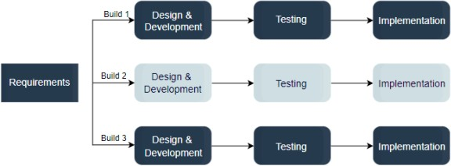

***Figure 4.1***

The iterative model allows you to see the results at the early stages of development. This makes it easy to identify and fix any functional or design flaws. It also makes it easier to manage risk and change requirements.

The deadline may change throughout the development process, especially for large complex projects. The iterative model is a good choice for large software that can be easily broken down into modules.

# 5.Project Planning

|  |  |  |
| --- | --- | --- |
| **Sr No.** | **Task To Complete** | **Estimated Time** |
| **1).** | Project and Objective Identification | 1st August 2022 - 20th August 2022 |
| **2).** | Documentation | 21st August 2022 - 10th September 2022 |
| **3).** | Requirement Gathering | 11th September 2022 - 20th September 2022 |
| **4).** | Analysis Phase | 21st September 2022 -26th September 2022 |
| **5).** | Design Analysis | 27th September 2022 – 4th Octomber 2022 |
| **6).** | Coding and Development | 5th Octomber 2022 – 10th November 2022 |
| **7).** | Testing and Validation | 11th November 2022 – 18th November 2022 |
| **8).** | Future Work | 18th December 2022 Onwards |

***Table 5.1***

**Note:-**Talking About Future Work if we observe while doing any task we see new things evolving over a period of time and new features coming all the way day by day so keep updating our project we need to update our deployed application by adding something new to it and everything cannot be done in just couple of months so that’s why updating things is necessary.

# 6.System Requirement Study

* 1. **Functional Requirement**
     + Public Blog Application is a web application in which it can be used for particular group of people or can be publicly deployed for people for publishing there ideas with the registered users.
     + Public Blog Application Contains several features like Post ,Edit ,Delete ,Like ,Comment, Comment(Edit,Delete), Image Posting by Image URL from Internet.
     + Public Blog Application usually focuses on user requirements suppose the one who wants to write also wants to read along with that user can be provided like and comment feature to appreciate posts.
     + We use Javascript to provide the best experience to the user by not posting anything irrelevant only posting good ideas and terminology infront of the other users.
     + In Public Blog application we delete anonymous users who do not provide right identity as well as they do not post anything over a period of time so there will be no glitch in the entire application.
     + This system will be very safe and the functionality will be very easy to be used by the user.
     + The user can access the public blog application from any device wheather it’s Laptop, Monitor or Mobile Phone, The Application is fully responsive.
     + The user’s registered data will be kept safe and the personal information of the user in the system will not be disclose to anyone.

# Non-Functional Requirement

* + - System should be user friendly and easy to use.
    - System shall provide attractive graphical interface for the user.
    - System shall allow the developers access to installed environment.
    - System shall allow the user to update their profile.
    - User should be helped appropriately to fill in the mandatory fields in case of invalid input.
    - User Will experience fast performance through out the session.
    - User Data will safely be saved in the database of system and it will not loss or damage.
    - Personal Data of the system should not disclose to anyone.
    - User can access the website across cross-platforms devices and it is web responsive.
    - System running on one platform can easily be converted to run on another platform.

# 7.System Design

* 1. **Use-Case Diagram**

The purpose of a use case diagram in UML is to demonstrate the different ways that a user might interact with a system.

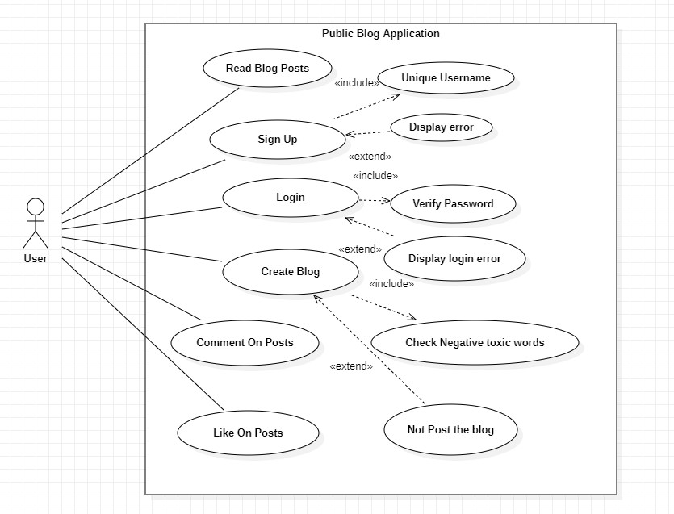

***Figure 7.1***

# Class Diagram

So a class diagram is simply a visual representation of classes you've defined. The diagrams describe class structure, attributes, specifications, and behaviors, as well as the relationships among various classes.

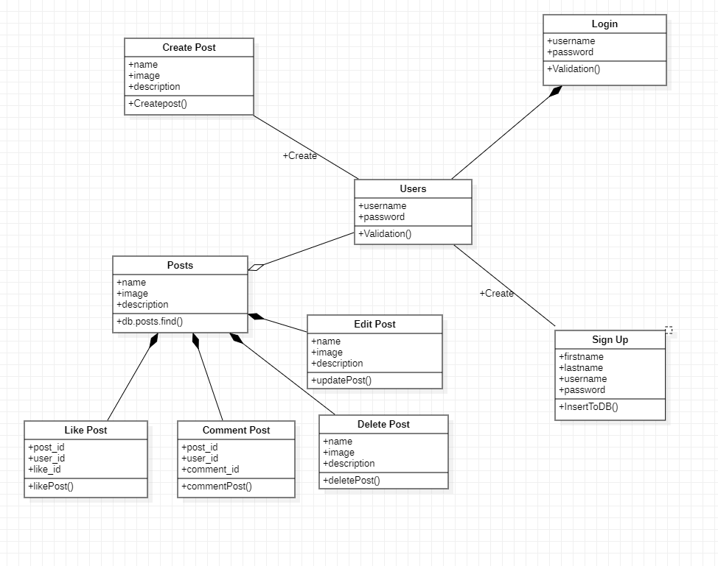

***Figure 7.2***

# Sequential Diagram

The sequence diagram is used primarily to show the interactions between objects in the sequential order that those interactions occur. Much like the class diagram, developers typically think sequence diagrams were meant exclusively for them.

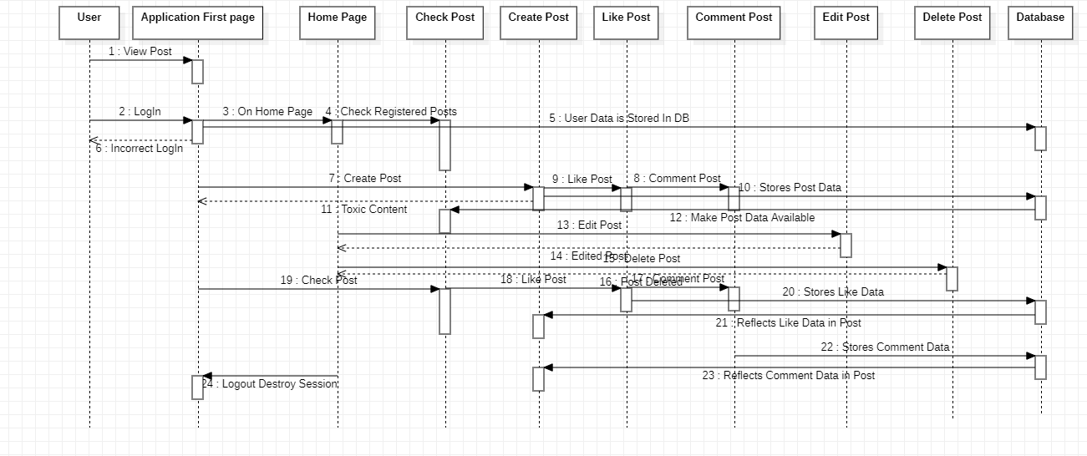

***Figure 7.3***

# Activity Diagram

An activity diagram is a behavioral diagram i.e. it depicts the behavior of a system. An activity diagram portrays the control flow from a start point to a finish point showing the various decision paths that exist while the activity is being executed.

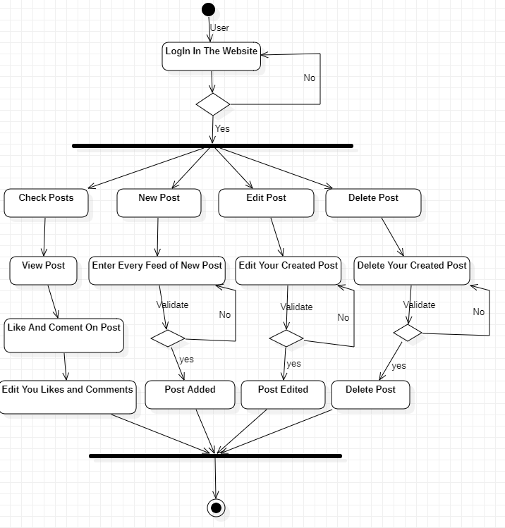

***Figure 7.4***

# Data Flow Diagram

A data flow diagram (DFD) is a graphical or visual representation using a standardized set of symbols and notations to describe a business's operations through data movement.

**Level:0**

It is also known as a context diagram. It's designed to be an abstraction view, showing the system as a single process with its relationship to external entities. It represents the entire system as a single bubble with input and output data indicated by incoming/outgoing arrows.

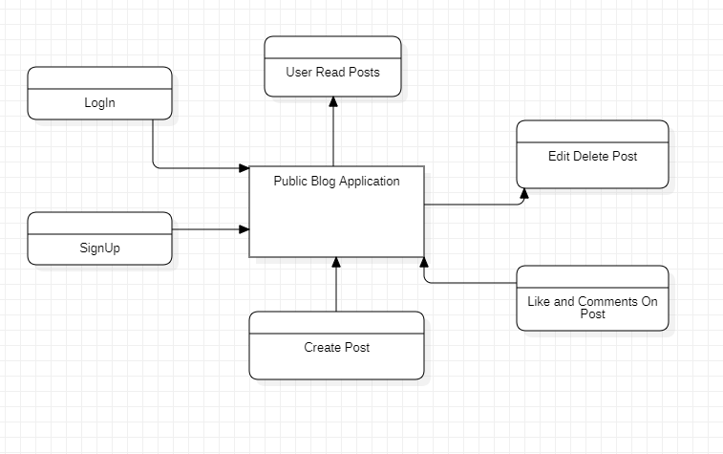

***Figure 7.5.1***

**Level:1**

The single process node from the context diagram is broken down into sub-processes. As these processes are added, the diagram will need additional data flows and data stores to link them together.

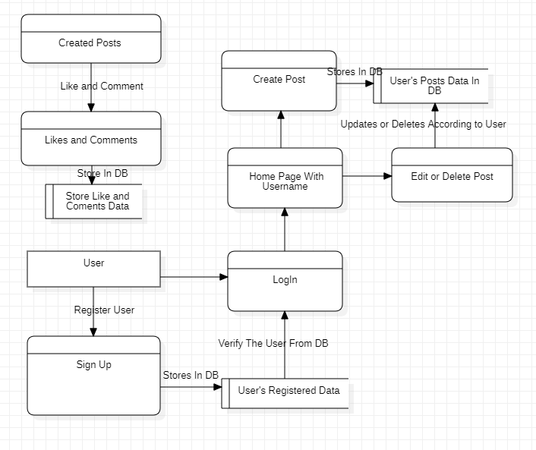

***Figure 7.5.2***

**User SignUp/Login Table:-**

# 8.Data Dictionary

|  |  |  |  |
| --- | --- | --- | --- |
| **SR NO.** | **Field Name** | **Datatype** | **Explanation** |
| **1).** | Firstname | String  {maxLength:20} | For User First Name |
| **2).** | Lastname | String  {maxLength:20} | For User Second Name |
| **3).** | Username  (Unique) | String  {maxLength:40} | For Unique Identity of user |
| **4).** | password | String  {maxLength:8} | For User Personal Password |

***Table 8.1***

**Post Table:-**

|  |  |  |  |
| --- | --- | --- | --- |
| **SR No.** | **Field Name** | **Datatype** | **Explanation** |
| **1).** | Name | String  {maxLength:150} | For Storing Tittle of new Blog |
| **2).** | Image | String | For Storing Image of new Blog |
| **3).** | Description | String  {maxLength:1000} | For Storing Description of new Blog |
| **4).** | Author_id  (Unique) | String | For reflecting by which user the blog has been created |

***Table 8.2***

**Comment Table:-**

|  |  |  |  |
| --- | --- | --- | --- |
| **SR No.** | **Field Name** | **Datatype** | **Explanation** |
| **1).** | Text | String  {maxLength:100} | For the Comment Text |
| **2).** | Author_id  (Unique) | String | For reflecting by which user the comment has been done |
| **3).** | Username | String | For reflecting the specific user |

***Table 8.3***

**Like Table:-**

|  |  |  |  |
| --- | --- | --- | --- |
| **SR No.** | **Field Name** | **Datatype** | **Explanation** |
| **1).** | Like_id | String  {maxLength:1} | For storing each and every like as per id |
| **2).** | Author_id  (Unique) | String | For reflecting by which user the Like has been done |
| **3).** | Username | String | For reflecting the specific user |

***Table 8.4***

# 9.Algorithm In Application

For Making our project “Public Blog Web Aplication we have used the REST API.

A RESTful API is an architectural style for an application program interface (API) that uses HTTP requests to access and use data. That data can be used to GET, PUT, POST and DELETE data types, which refers to the reading, updating, creating and deleting of operations concerning resources.

In our project we wanted the user to post the Blog Read and Write the blog Edit and Delete his/her blog along with that we also wanted our users to like and comment on that particular blog.

So for that we have used several methodologies like GET, PUT, POST, DELETE to deal the database and application.

Steps:-

Step-1: Name of the endpoint should be accompanied by the HTTP method. Step-2:Return standard error codes according to the result of our API.

Step-3:Endpoints name should be plural Step-4:Routes Should be perfectly Specified

Step-5:Any Port number should be fixed while performing you code

# 10.Test Cases

|  |  |  |  |  |  |
| --- | --- | --- | --- | --- | --- |
| SR NO. | Test Cases | Input Test Data | Step to Execute | Execute Output | Pass/Fail |
| 1). | Registering  The user | Fill Correct First Name,  Correct Last Name,  Correct Username as Email,  Strong Password | i).Enter First Name  ii).Enter Last Name  iii).Enter Email as username  iv).Enter Password | After filling this details correctly the user will be LoggedIn redirected to the home page. | Pass |
| 2). | Login The  User | Fill Correct User name,  Enter Correct Password  (Note:-In this case the user must be registered first then only he/she can Login else they have to register) | i).Enter Email as Username  ii)Enter Correct Password | After filling this details correctly the user will be LoggedIn redirected to the home page. | Pass |
| 3). | Create Post | Fill appropriate title of blog post,  Copy any image address from the internet related to blog and copy in the image section,  Write appropriate description for your blog | i).Write Appropriate title for blog post  ii).Enter Correct Image URL from the internet related to blog post  iii).Write appropriate blog description | The Blog post will be successfully created after performing the steps and that post will be seen by eachand every user. | Pass |
| 4). | Edit Post | To edit the post click the edit button and then edit whatever column you want to edit and click save. | i).Click Edit Button  ii).Fill the details that you want to edit in your blog post  iii)Click on Save button | The post will be edited and will reflect in the posts again,It will be updated completely | Pass |
| 5). | Delete Post | To delete your blog post simply by clicking on the delet blog button. | i).Click on the delete button  ii).Check to know if the post is deleted or not | The post will be deleted and will also be unavailable in the MyPosts Section | Pass |

# *Table 10.1*

# 11. User Manual

When you type localhost:3030 on the browser search bar after successfully running you code with no error you will observe,

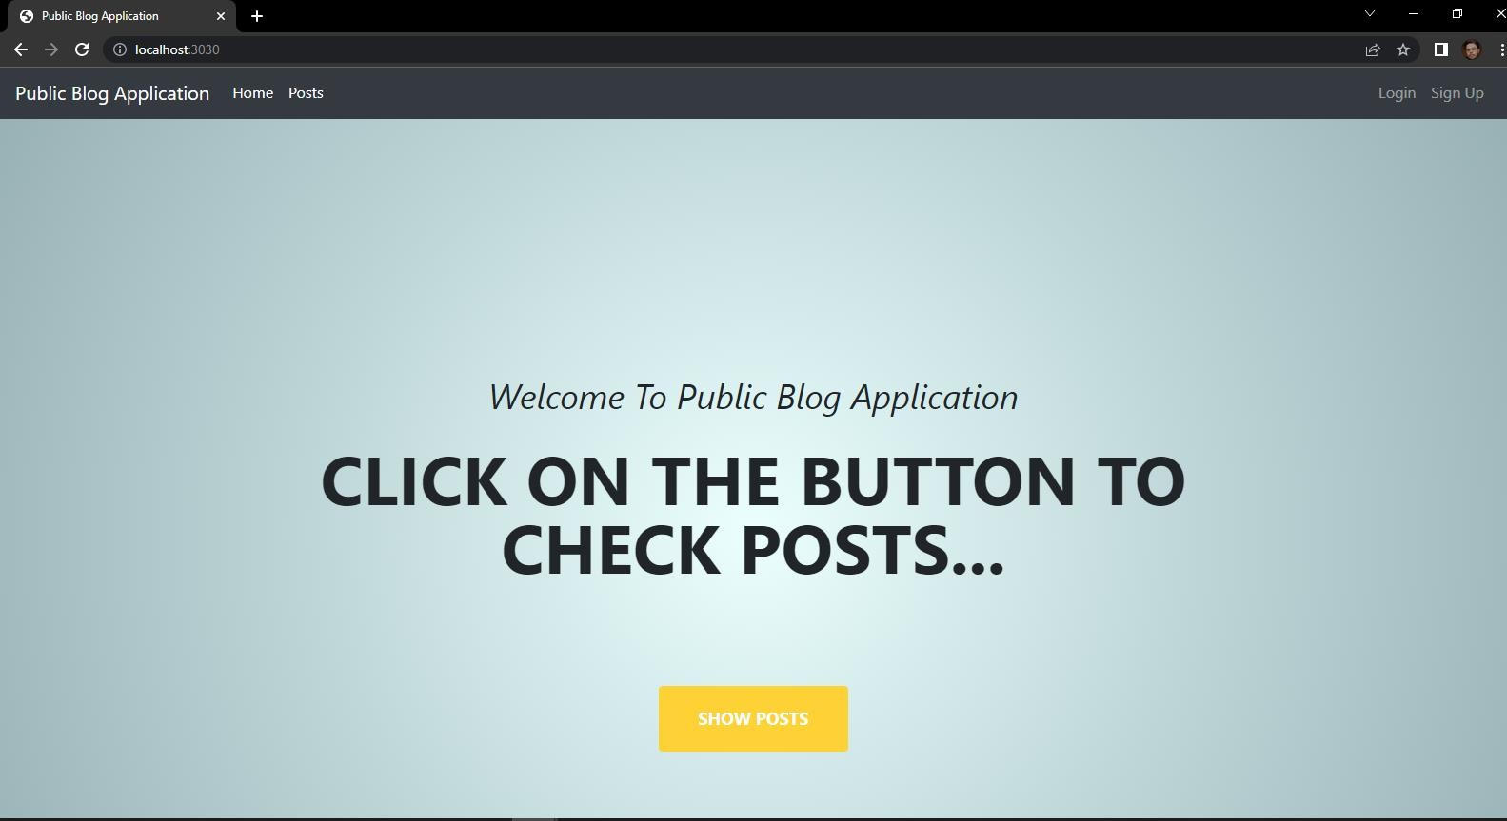

***Figure 11.1***

After that lets say you are a user who doesn’t want to signup and login then you can continue reading the blog by clicking on the show posts button or posts button.

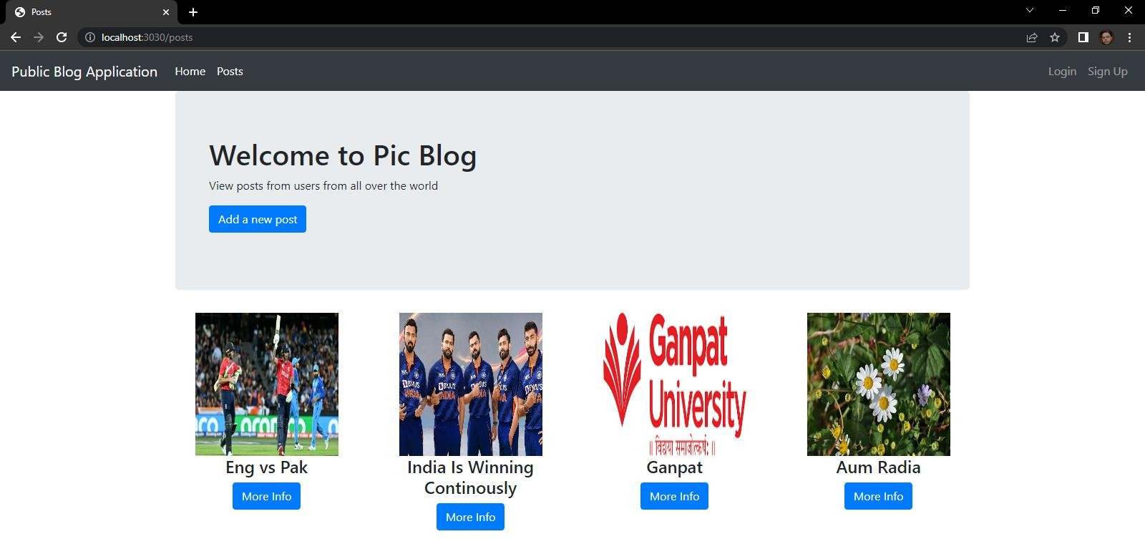

***Figure 11.2***

Now If the User Wants to read any blog which is already created then it can read by clicking on More Info Button.

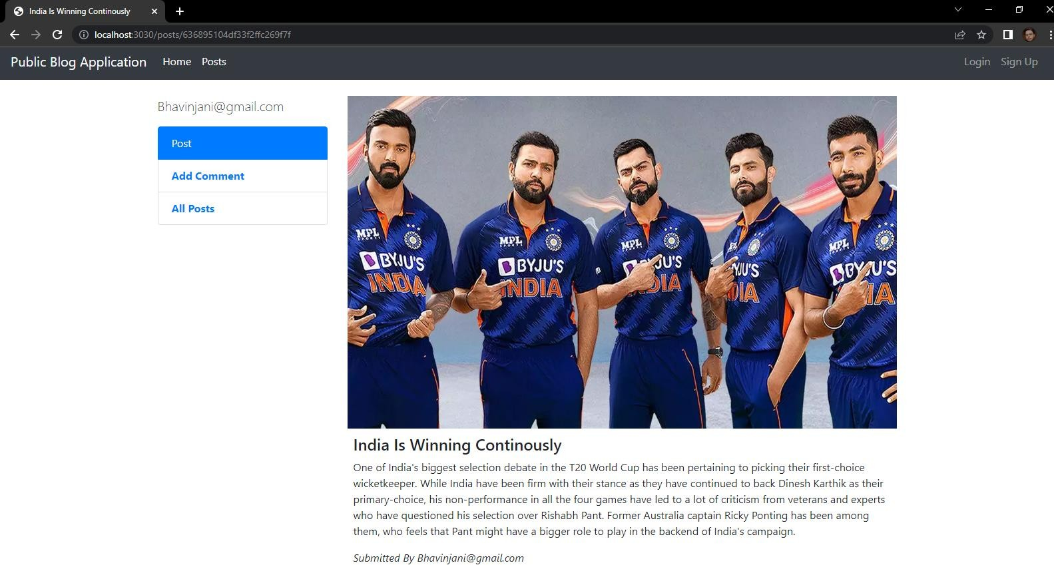

***Figure 11.3***

Now let’s say if any user wants to like or comment on that particular post then they cannot directly comment and like but for that firstly they have to signup.

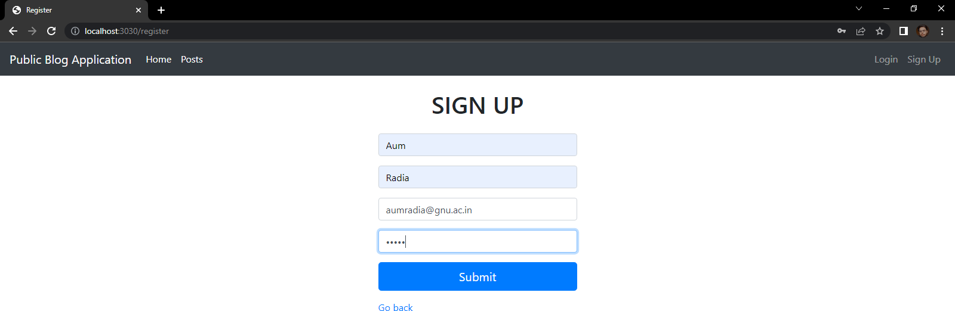

***Figure 11.4***

Login Screen

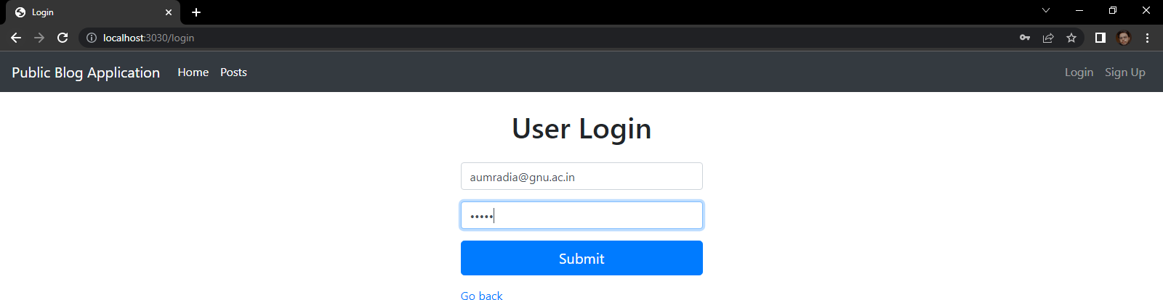

***Figure 11.5***

Now as we can see that the use who has logged in into the application his/her user name will directly reflect in the navbar so that the user gets to know that he is logged in and can perform several functionalities.

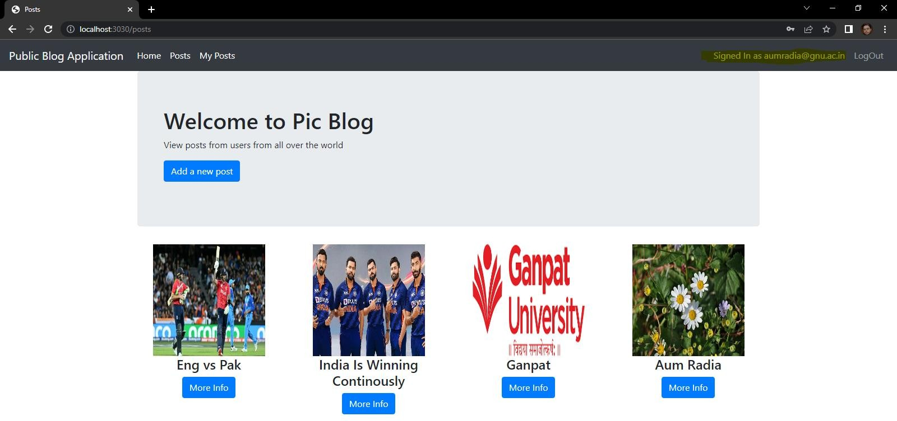

***Figure 11.6***

Now the user who is already logged in can post the blog very easily by simply clicking on the Add a new post button.

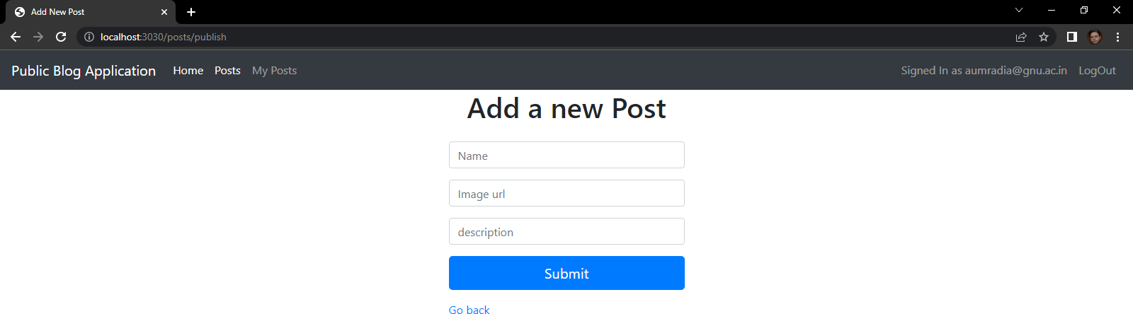

***Figure 11.7***

Now fill in the details which you want to post in your blog but always remember that in our blog application we are providing a new feature in which you can directly upload any image from the internet you just have to enter the url of that image which makes it very easy for the user.

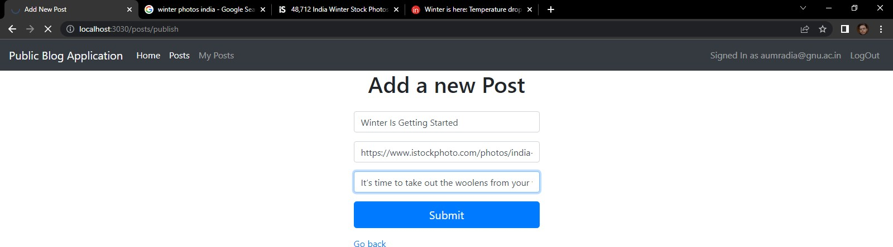

***Figure 11.8***

Now the post that you have created will directly reflect on the main home page along with you onw created blog page which is “My Posts” and that post will be publicly in read mode and can be liked and shared.

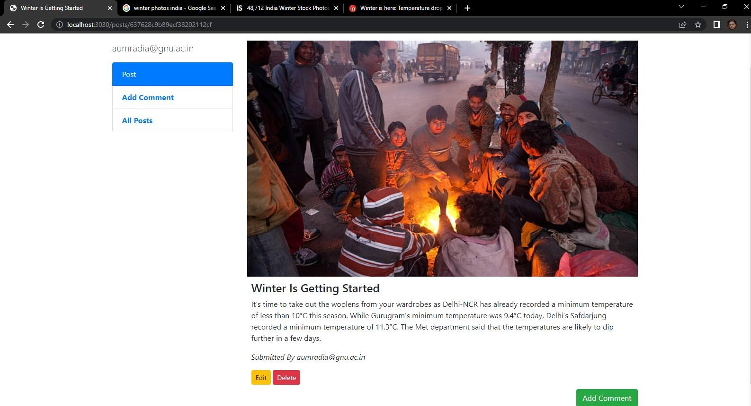

***Figure 11.9***

Now the user who has created the post can also edit and delete that post by simply clicking on the buttons which are given in the webpage.

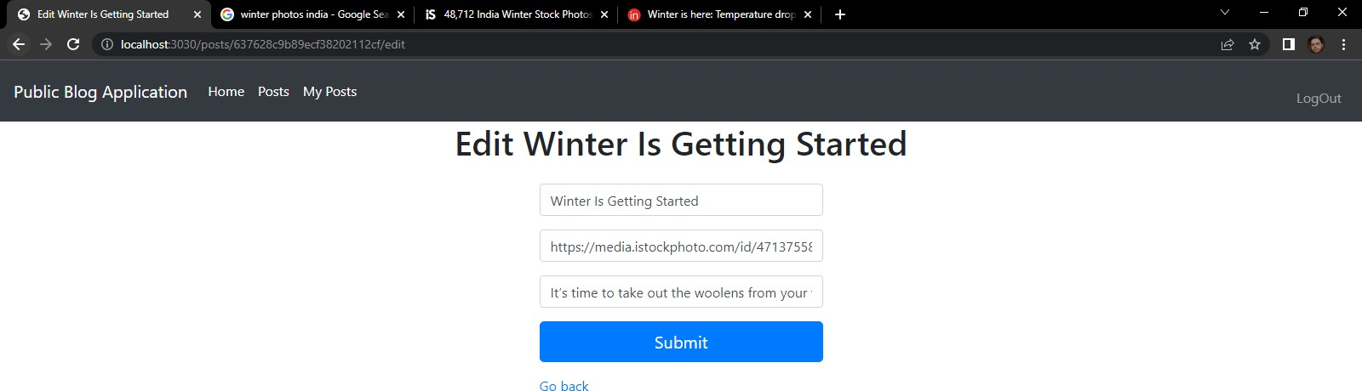

***Figure 11.10***

You can check you post on the My Post my simply clicking on it.

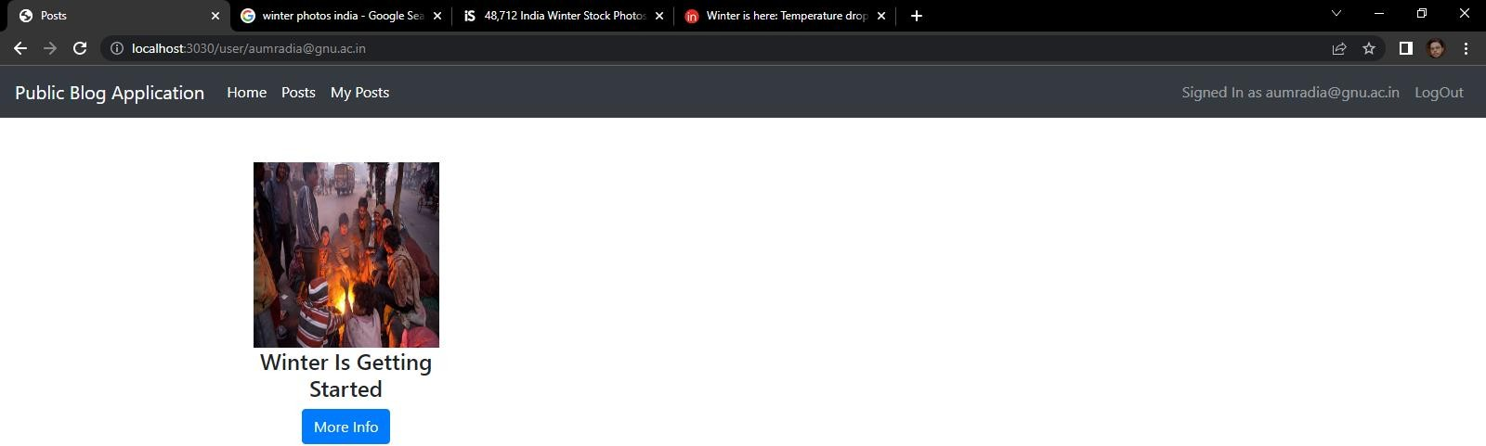

***Figure 11.11***

Now you or any user who like this post can also comment on this post as well.

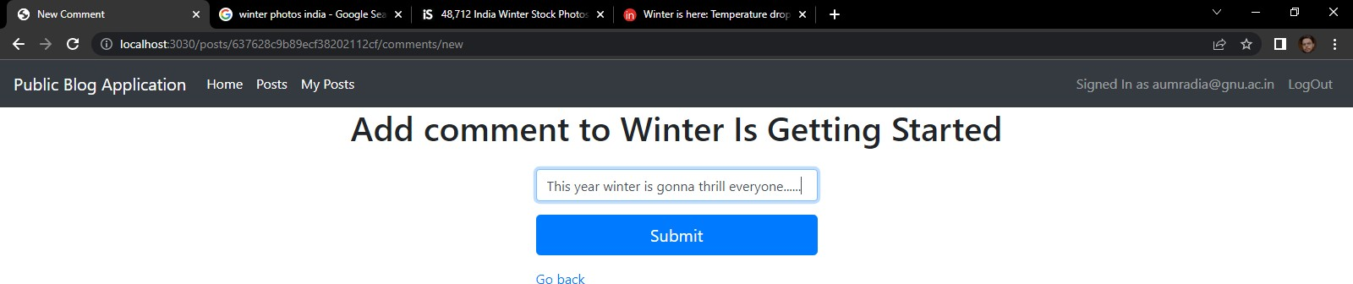

***Figure 11.12***

And Along with that you can also edit and delete you comment as well…

Our Application is also Mobile Responsive so it can be used by both the laptop as well as mobile user’s.

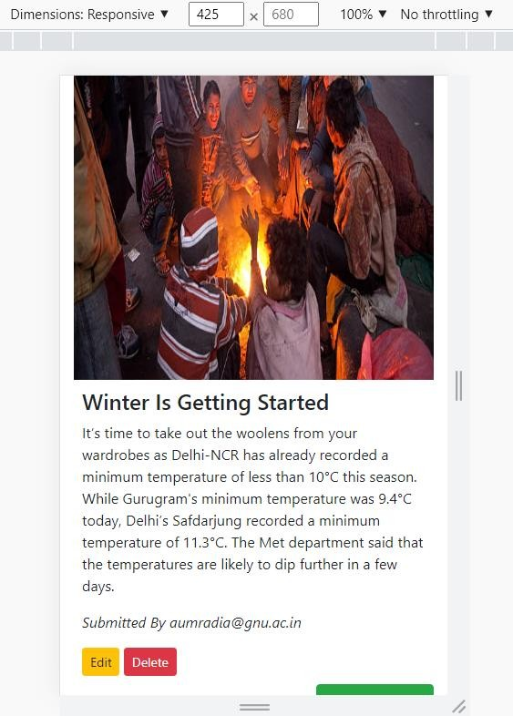

***Figure 11.13***

After that we also provide facility for the user to logout of the system by which the user can feel secure, And after that the user’s session gets expired.

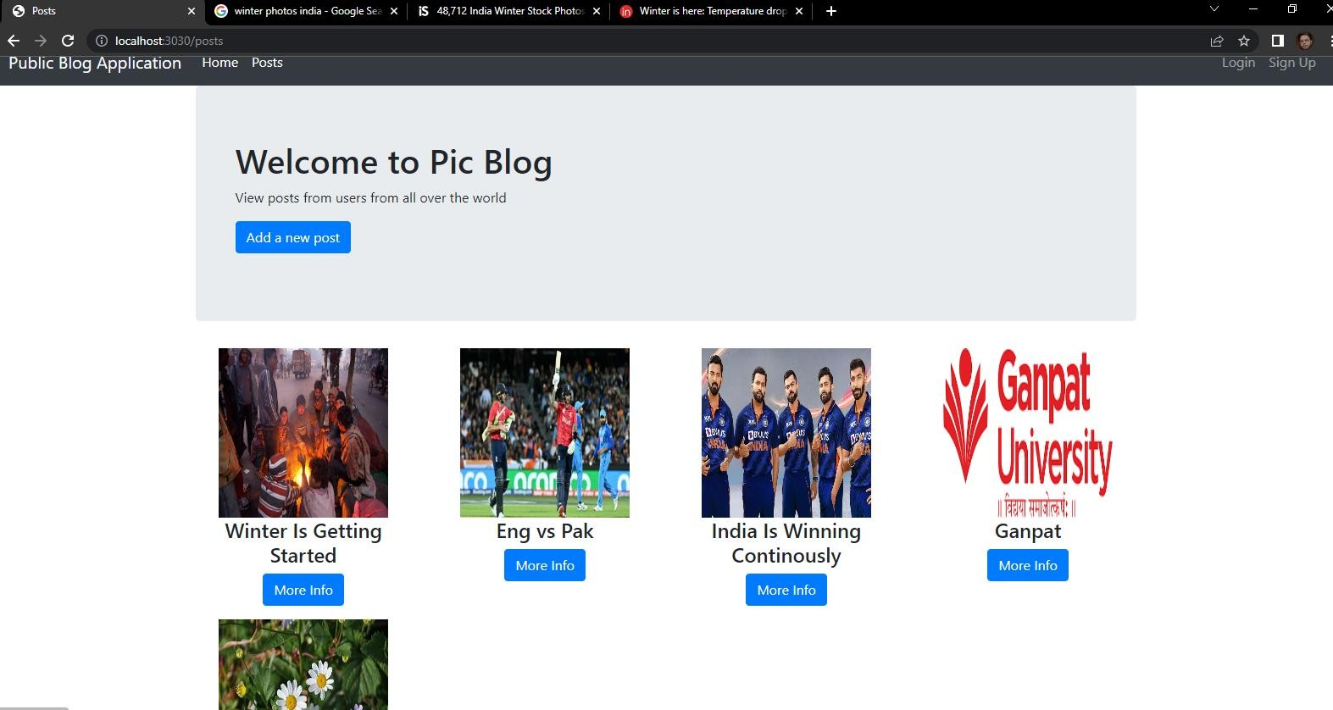

***Figure 11.14***

# 12.Conclusion

Public Blog Application is a web based application which will be working on the ground level or local level in which normal people can share there ideas and stories by writing a blog, While creating a blog the user can give a super short and appropriate title which suits his ideas or story when the user is publishing his blog along with that the user can also put an image to describe the view and imaginary thoughts of his blog after that user can give a brief introduction about his ideas or story and can post among people.

Describing on the advanced level the user can like the blog posts of other people and along with that they can comment on the other people’s blog application, trust me it’s very easy and simple.

And at the end we would like to conclude that in our project there is much more we can do like we can add more number of functionality by deeply researching on different edges of technologies and we make sure will update and add new features time by time and will surely notify you on regular basis.

# 13.Future Work

Talking about the future work we will update the user experience and user interface on monthly basis after deploying our application and after that as our project is Public Blog Application so in this project we can add more number of functionality and features.

The kind of features that we can implement in the future is that like the user who want to write a blog that process can be achieved by simply speaking and the description of the project will go with the flow and will check the content of the blog wheather it is good or bad and according to that user will be able to post the blog.

Others features that we can implement in the future are like we can set topics drop down list in which user can read the posts accordingly to his or her interest, like lets say the user only likes to read blog on cricket so in this case the user can select the specific topic and in that topic they can read the registred blog of that particular topic easily.

And later on we will provide the user to edit his description by giving the text editor tool in which the user can edit text description by there own very easily, along will that we will also provide the user to add multiple images for posting a single blog post which can make the user readability idea a very clear one.

They main thing that we are going to add in this project is the scalability term which allows thousands of users to use the application on a single parallel time, so we will definetly think to scale our project at our best.

# References

1. In Our Project “Public Blog Application” to understand the removal of toxicity in the blog content to make the content more efficient and precise we have gained literature survey from.
   1. [https://towardsdatascience.com/toxic-comment-classification-using-lstm-and-lstm-cnn-](https://towardsdatascience.com/toxic-comment-classification-using-lstm-and-lstm-cnn-db945d6b7986) [db945d6b7986](https://towardsdatascience.com/toxic-comment-classification-using-lstm-and-lstm-cnn-db945d6b7986)
2. To Understand how to fetch the registered data from the database while dealing with MongoDB I have gone through,
   1. <https://www.w3resource.com/mongodb/mongodb-queries-from-collection.php>
3. Secondly to learn how a blogging application is built in node,js we have gone across many websites and understood how to make a efficient project by using simple line of code and what databases to use for easily retrevial of the data through the REST API.
   1. <https://vegibit.com/node-js-blog-tutorial/>
4. Thirdly to know how to add the comment on the blog feature I have learned from, <https://makeschool.org/mediabook/oa/tutorials/reddit-clone-in-node-js/comment-on-post/>
5. Now after learning all these things to know about the actual architecture on how to build a great UI(Frontend) so that the user finds it good to use our application I have gone through many blogging websites which are,
   1. <https://medium.com/>
   2. <https://www.blogger.com/about/>
   3. <https://wordpress.com/>
   4. <https://www.weebly.com/in/features/start-a-blog>

# About College

Our spirituous efforts are directed towards leading our student community to such an acme of technical excellence that can satisfy the requisition of the industry, the nation and the globe at large. The generation of an entirely different community of students aiming at attaining technical expertise and utilizing the technical know-how in the service of mankind is at the root of our efforts. We have the following aims before us.

* To offer guidance, motivation and inspiration for full growth of hidden traits
* To impart technical and need-based education by conducting elaborated training programs.
* To shape and mould the personality of future generation
* To construct fertile ground for resting dire challenges
* To cultivate the feeling of belongingness amongst the faction of engineers

**Establishment:**

U. V. Patel College of engineering (UVPCE) situated in Ganpat vidyanagar campus was established in septmber-1997 under the aegis of Mehsana District Education Foundation with a view of educating and training young talented students of Gujarat at the field of engineering and technology to meet the needs of industries in Gujarat and beyond for the growth of the industries.

The College is named after Shri Ugarchandbhai Varanasibhai Patel, a leading industrialist of Gujarat, for his generous support. It is a self-financed institute approved by All India Council for Technical Education (AICTE), New Delhi, the Government of Gujarat and now it became the constituent college of Ganpat University.

The College is spread over 25 acres of land and is a part of Ganpat vidyanagar Campus. It has two ultra- modern buildings of architectural splendor measuring 6100 sqm. and 2700 sqm., for housing class rooms, tutorial rooms, seminar hall, offices, drawing hall, workshop, library, well equipped different departmental laboratories, several computer labs with internet connectivity through 1 Gbps Fiber link, satellite link education center with two-way audio and one-way video link with Gandhinagar etc.

Placement plays a key role in shaping the future of the students, and keeping this in mind; the institute has forged healthy relations with the prominent industries. These tie-ups are mutually beneficial. The industries get a chance to employ the resources of the institute for their R & D. In turn they extend every possible help to the institute especially with regard to providing hands-on training to the students. As part of this initiative, Incubation Centre/Start-up activities have also been developed.

Ganpat University and the township of Ganpat Vidyanagar, a high-tech education campus is a joint initiative, purely philanthropic in nature, by a large number of industrialists and technocrats, noble farmers, and affluent businessmen for the mission of “Social Upliftment through Education”. The University is established by the State Government by the enactment of Act No.19/2005 on 12 April 2005. In consideration of its contribution to the Education in a short period of time, the University has been given Permanent Membership of Association of Indian Universities (AIU), New Delhi besides having membership from the Association of Commonwealth Universities (ACU), UK, and International Association of Universities (IAU), France.

Ganpat University offers various unique, quality, industry-linked, and sector-focused Diploma, Undergraduate, Postgraduate, and Research level programs (Professional and Non-professional) in the field of Engineering, Management, Computer Applications, Pharmacy, Sciences, Commerce & Social Science, Architecture, Design & Planning, Maritime Studies, Law, etc